# What is What

**What is What**

## Overview

*Overview of User interface and how it communicates with another layer/interface.*

## Splash Page

### Interface



[Figure 1]

### Description

*This is the Splash Screen of Application, it is displayed when the screen launches*

## Login Page

### Interface

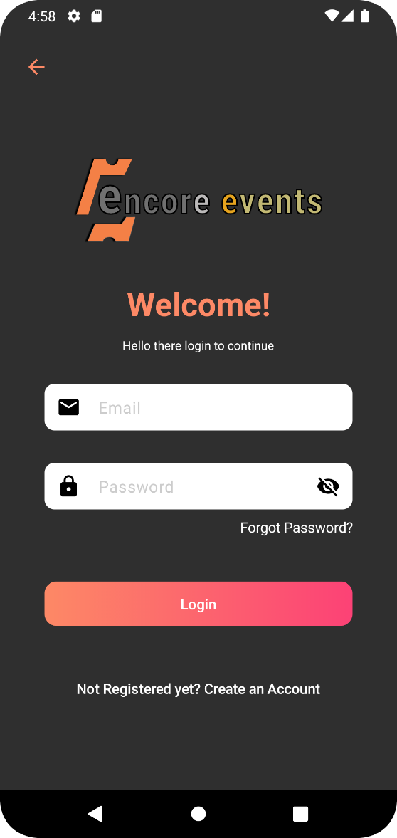

[Figure 3]

### Description

*This is the login screen, where user will add his valid email and password for further login. This screen will be displayed when user opens the app for first time and also in case user is not logged in to the application..*

## Company Registration Page

### Interface

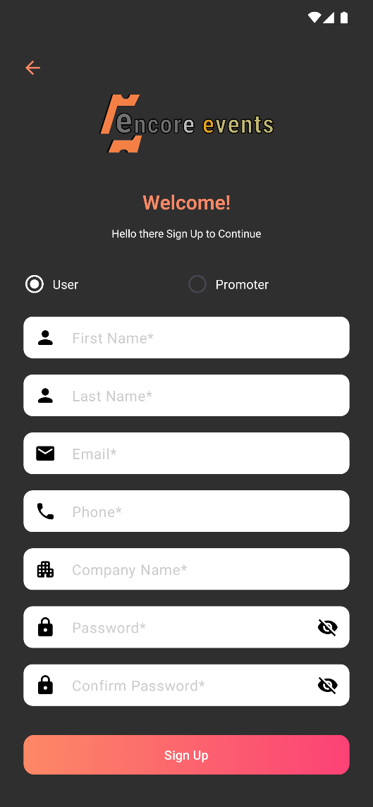

[Figure 2]

### Description

*This is screen will appeares when user choose fro signup with the application from login screen. Here user fill all required filled and click Sign Up button then user can get the confirmation mail to register email-id after confirmation we are able to login into application*

## Forgot Password Page

### Interface

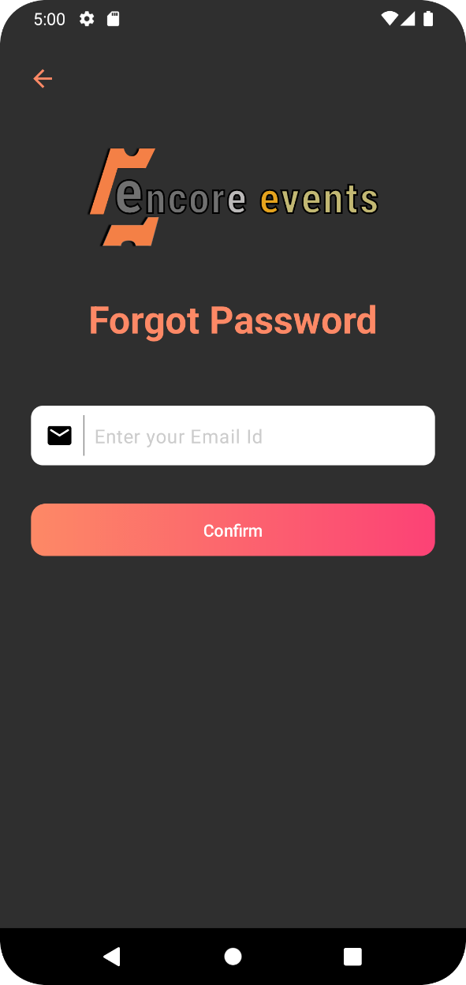

[Figure 5]

### Description

*This screen would be used, if user forget his password. User need to enter his registered email-id to get the OTP. After that [Figure 6], screen would appear to change the password.*

## Forgot Password Page

### Interface

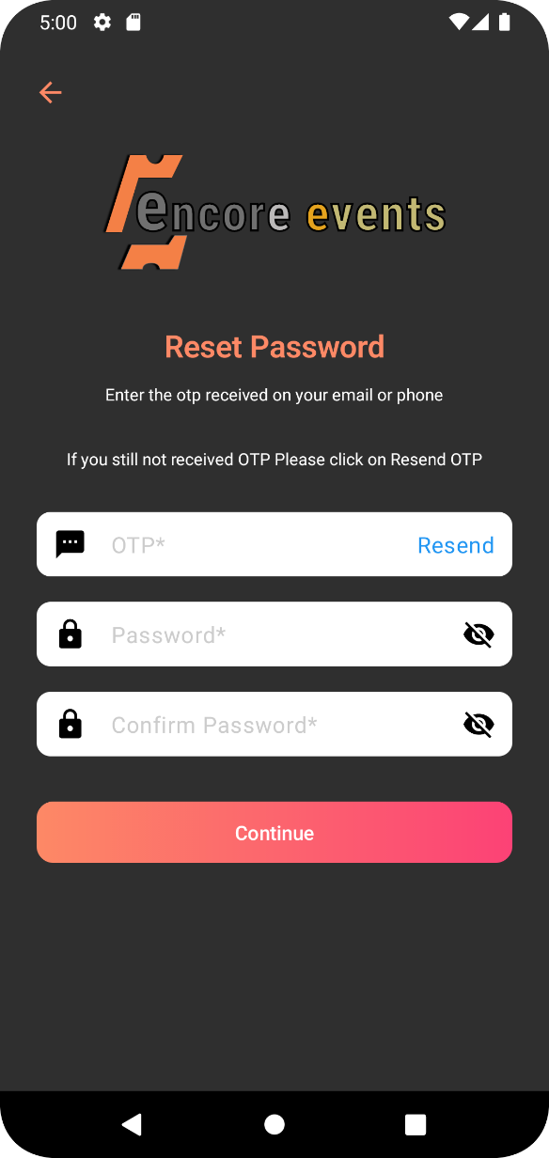

[Figure 6]

### Description

*This screens would be used, verify otp and set new password.*

## SideMenu Page

### Interface

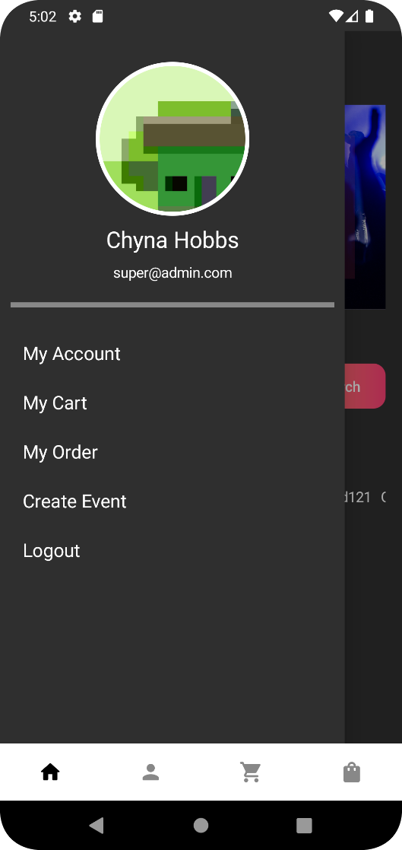

[Figure 7]

### Description

Above is Side Menu page of the application.it has multiple task to be performed like logging out create event. we also showing the profile picture of user and his/her email id. All Modules of application is appear here.

## Profile Page

### Interface

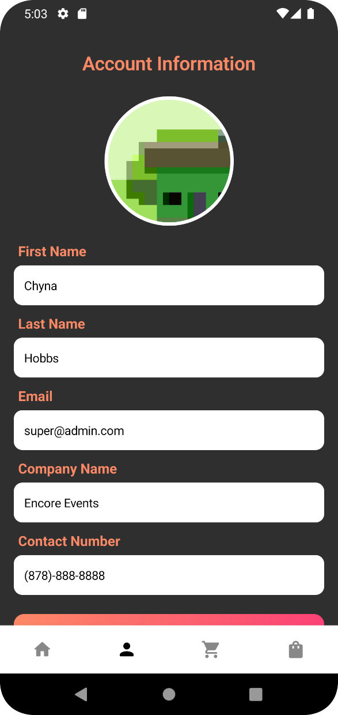

[Figure 7]

### Description

Above is user profile screen with user details. is used see the screen like this screen is used to display the information of account holder here the user can change their profile name, contact number and company name. Email id is not editable.

## Edit Profile Page

### Interface

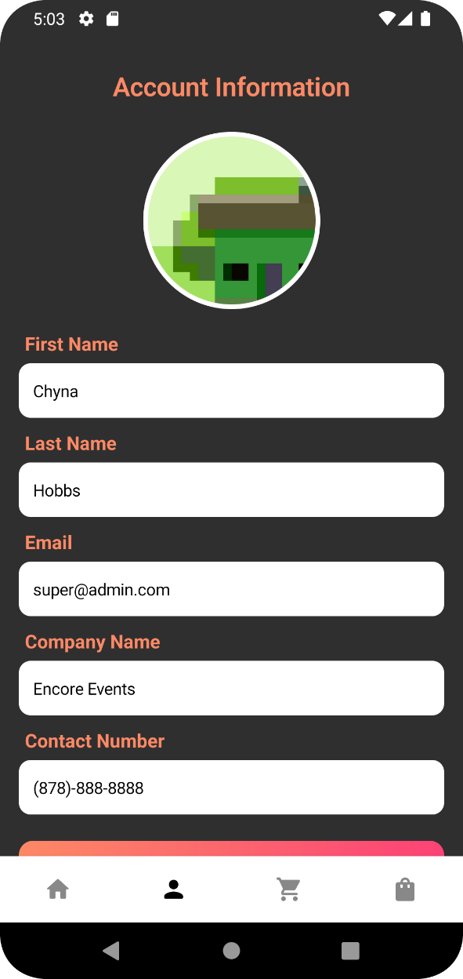

[Figure 7]

### Description

Above is the Edit User Profile of the application. Its is used to edit personal info added during signup. It is used see the screen like this screen is used to display the information of account holder here the user can change their profile name, contact number and company name. Email id is not editable.

## Home Screen

### Interface

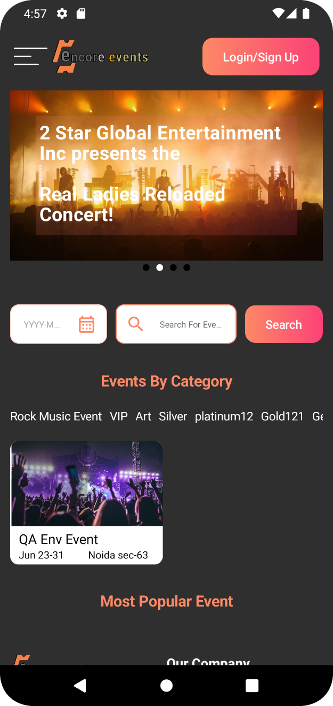

[Figure 7]

### Description

Above is Home Screen of the application. This screen is showing the event details. This screen is visible to user with or without signup if user want to buy a ticket for a event he need to login into application. Home screen contains banner image, event category, most popular event and company address.

## Create Event Page

### Interface

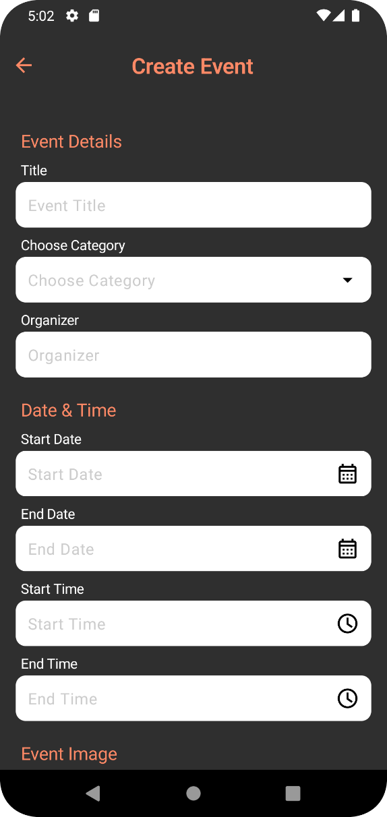

[Figure 4]

### Description

Above is Create event page of the application. For this screen you create a event for creating event you can fill the required filed on click of save event your event is created. In create event screen we need to enter start date and end date for event.Here we list out all the information like zipcode, address, state, organizer, event title and start/end date.